FelRh018Hafoty
31.1.2002 DRAFT 4
3.07.02 –D5

TEULU- HAFOTY & CAEGLAS, CROESOR-FAMILY

We are treading the paths of our ancestors and the many other pilgrims who had also tried to record and interpret the past. We are dependant and grateful for what they have recorded. Part a) deals with Croesor’s background; part b) deals with the ancestors of Dafydd William up to1809 and in part c), with the history of Margaret Prichard & Dafydd William’s family. For Margaret Pritchard’s history prior to 1809, see the Rhyd ddu family Fel Rh017.
Hafoty (Foty’r Garreg Fawr) was at one time a smallholding. It is a long low building and could have been divided into two or three parts as today (2002). Part of the long house could also been used to house animals. The building could well be pre- Tudor age. Today it is one abode belonging to the Brodanw Estate. On the chimney beam we see a number of graffiti and one looks like “W L 177?” (see Photo ). It was a t Hafoty that J.R.Jones lodged between 1789 & 1804 with Owen Jones the weaver and his wife Mary Jones. We see that others of the Owen Jones family lived at Garreg fawr. Today Ty newydd Caeglas is a ruin. It was here that Griffith Dafydd was born in 1816 and Humphrey Jones ( Bryfdir the poet) in 1867. Ref 3 Bryfdir describes his early childhood at Ty Newydd.
- Hafoty and Caeglas (Ty Newydd) (O.S 629432 & 629449 ), Croesor are less than a mile apart on the old
Roman Road from Tan y Bwlch to Beddgelert/ Caernarfon and in the parish of Llanfrothen. The establishment of the Sunday school, towards the end of the 18th and the beginning of the 19th century, is well documented in ref ( 1 ) “History of the Sunday School in the Ffestiniog area”. The book was published about 100yrs after the events but just within memory at the time.

William Lewis and his assistant, Gwen Jones, set up the Sunday school circa 1796 at his home, a small holding called Hafoty. In Tudor times, this mainly farming area was amongst the most highly taxed ( tithe) area in Meirionydd. The sea lapped the rocks on which the ancient Church of Llanfrothen stands and nearly reached the bridge at Aberglaslyn. The chart, (FelRh052), shows four centuries of events and people in the parish. Apart from the coming & demise of the quarries and the consequent change in population, nothing much has changed in the Cwm- “Y cwm tu allan i’r byd” . The essay by Glaslyn, in ref. 2 describes Cwm Croesor.
On reading the references below, it is difficult to extract the true history of the beginning of the school, its location and its movement, but a picture emerges of the early establishment of a Methodist Sunday school in the parish and one of our ancestors, William Lewis, was certainly involved. He was the next-door neighbor of the renowned Baptist, J.R. Jones of Ramoth. Their time was a time of religious persecution and awaking, and learning to read and write. At Llanfrothen it was a turbulent three-corner fight for the minds and size of the congregation. In the ‘religious ring’ were three contestants, all named Richard viz;- Richard Pughe, the parson of the old established Church, J.Richard.Jones the Baptist and Richard Jones Y.Wern, for the traditional Methodists; the later was aided by Hafoty. The ‘schoolroom’ was small and consisted mainly of children. William Lewis could read and Gwen Jones was intelligent and wise (ddeallgar). They preached and kept Siâts (society) at various farmhouses and cottages, viz Ogof Llochwyn & Hendre Gwenllian.

b) There is a wealth of information regarding David Williams’s family. Briefly his father William Lewis is the infant recorded at Llanfrothen “ William son of Lewis Jones ( Lewis Mordecai)” Are there any connection with Mari Lewis” ( an eccentric woman –un rhyfedd, ) who lived with her husband Morus Rolant at Croesor Bach)? If so, there is a good description of them in ref. 2 The only reference we have of his mother,Margaret Lloyd, is that of her marriage at Llanfrothen Saturday, the 17th of April 1773. Again we can ask, “what are the connections, if any, with the many Lloyds of the area ? ” In particular Dafydd Lloyd ( Lloyd George’s grandfather) and John Lloyd Williams ( Edgar’s etc grandfather) We read that William Lloyd’s family left the district. We do not know why they left. Was is work or religious reasons? Where to? Penrhyn, Llanddwywe.. ? Did they move to Ty Newydd Caeglas from Hafoty before they left- this is stated in ref 1. Did the whole family move? No burial records of Margaret Lloyd & William Lewis have been found as yet. The Lewis family will be the subject of a separate essay.
We know that David Williams had at least one sister, Elizabeth, who married John Owen of Croesor Fawr,- they were the parents of Glaslyn. There are other siblings ( 12 in all ) to David & Elizabeth; see FelRh021.

c) This is an attempt at the pre Victorian history of the Ty Newydd Caeglas family from the marriage of Margaret Pritchard & Dafydd Williams to the demise of the family with the death of Margaret, some time at Tanygrisiau?
It was a period of poverty and transition in Gwynedd with the industrial revolution in mineral (slates etc.), development of the railways ( Ffestiniog Rly – 1832/6) the building of roads and bridges ( A5 1815 and the Telford Menai suspension bridge 1826), the building of ship and the Cob at Porthmadog. The Cob was started in March 1808 and a Jubilee was held on the 17th of September 1811 when it was completed. Twm o’r Nant was one of the contractors but he died just before it was finished and. Hwntw Mawr killed a Llanfrothen girl at Penrhyn Isaf farm.
We see the story of the young Margaret Pritchard, before her marriage, in another paper. How and where did she meet Dafydd Williams we can only guess? Young couples meet by chance- somewhere, sometime and somehow and as evidence, I am writing this note ! The marriage is noted in St Mair’s church Beddgelert record book as follows : - “27.1.1809 by Banns David Williams, single, of the parish of Llanddwywe (Dyffryn Ardudwy) with Margaret Richards, single.” – a Friday.! We deduce that Dafydd Williams was aged 24 yrs old and Margaret was 30 yrs old in 1809. According to the baptismal records at Llanfrothen their five children were born at three different abodes in the Croesor area, between 1810 & 1817 as follows:-
19.5,1810 (31yrs) Lowry daughter of David Williams at Garregfawr (9625 431 ) (Hafoty ? ) and Margaret his wife (31)
22.9.1811 (32 yrs) William son of David Williams at Garreg Fawr & Margaret his wife.
26.9.1813 ( 34yrs)Richard son of David Williams & Margaret Richards, (Ha)Fotty (603 433) Labourer.
7.1.1816 (37yrs)Griffith ( Dafydd FelRhF) ditto Ty Newydd Cae Glas (626 457 ) Labourer.
15.5.1817 (38yrs) Margaret dau. Ditto
The dates given are the baptismal and not the birth dates. We can assume that the children would be baptised when they were a month or two old. The age in ( ) is the age of the mother at the time of birth. Note that the family were at home at Garreg Fawr/ Hafoty up to 1815 and at Ty Newydd Caeglas from 1815 to ?.
The battle of Waterloo was being fought ( 18.6.1815 ), the A5 to Bangor was in construction by Telford and six month later Gruffydd Dafydd was born. Today (2002), the abodes of Garreg fawr and Hafoty are in occupation. Ty Newydd Caeglas is a ruin ( see Photographs)

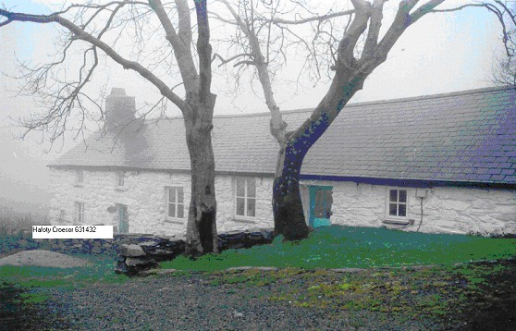
Hafoty, Croesor where William Lewis started a Sunday school c 1790

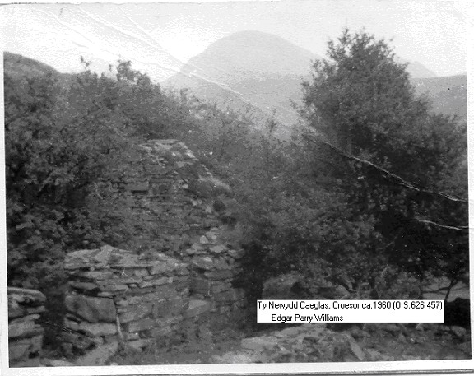
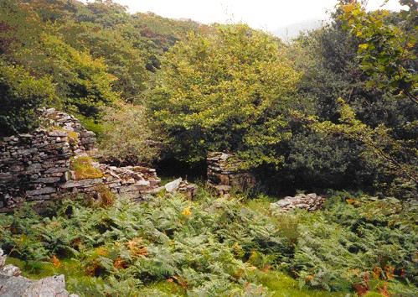

We read that William Lewis had left the district but that his son David William, whom he had taught to read & write, was a bit of a rebel against Methodism. About the year 1817 there was a religious revival at Beddgelert (Talyrni) where he had gone to barrack. He came away converted –possibly influenced by his wife. He carried on with his father’s school at Ty Newydd Cae glasuntil 1821.
On the 30th of March1821, tragedy struck the family with the death of Dafydd William at a young age of 36. He was buried at Llanfrothen (m.i. D026). The railed double plot has an august obelisk (fallen and broken the rails) with a number ( ) of burials recorded. We do not know the cause of his death. Was it an accident? The press reports for the period would be worth looking at ( e.g. North Wales Gazette ). The following is the record on the memorial ( G.F.H.S. book).
Er cof am/David Williams/Ty Newydd Caeglas/Yr hwn a fu farw Mawrth 1 1822(sic)/Yn 36 mlwydd oed/Er cof am Jane merch W’m a Jane Davies Gelli Goch isaf/ Yr hon a fu farw Ebrill 11 1860 yn 19 mlwydd oed/ Hefyd Margaret eu merch/Yr hon a fu farw Mai 27.1869 2/1 oed/ Er serchus goffadwriaeth am /Jane Davies/ Annwyl briod William Davies/ Bryn Derwen Minffordd/ Yr hon a fu farw Ebrill 7 1881/ Yn 73 Oed/ |Hefyd William Davies/ Annwyl Briod yr uchod /Yr hwn a fu farw Mai 15 1895 yn 89 oed ?/ Er cof am/ D. W. Davies/ eu annwyl fab/yr hwn fu farw Mai 10 1877/ yn 39 mlwydd oed
Yr Ior, pan ddelo’r enyd- ar diwedd/O’r Ddaer a’n cyfyd/Bydd dorau y byd/ Ar un gair, yn agoryd/R.ab Gwilym Ddu ( Bard).
.

Margaret his wife, who was aged 42 and with five young children aged between 11 & 4, must have been in dire straight. There was some form of Poor Law or Parish relief in force but this was before the Reform Act of 1834. Queen Victoria was not on the throne until 1837. The workhouse, if it existed and depravation was a threat to the young widow and her family. However living in a close community, like Croesor, was probably her salvation. Soon Lowry, the eldest, would be able to help. Margaret Pritchard was a relatively young person, brought up on a farm and could scratch a living as a servant/helper. They would have a smallholding with a few cows, a pig, sheep and some hens and a vegetable garden. Her parent were dead but her eldest brother, John ( 17 yrs older) aged 59 was still farming at Ffridd Uchaf at Rhyd ddu. Other members of the family and neighbours would also help her. There was a lot to be said for ‘cymdogion agos’
Be as it may, they moved from Croesor and the questions are:- Why and when did they move and to where? Blaenau Ffestiniog /Tanygrisaiu. Apart from a small handful of farms and houses, Blaenau and Tanygrisiau did not exist. Llan Ffestiniog was the centre of worship, administration, market and hiring fairs and burials at St Mihangel. The 1801 statistics for the parish of Ffestiniog i.e. North of the Afon Cynfal to the Moelwyn reveals a picture:- 120 houses.161 families and a total population of 732. By 1831, the population had gone up to 1648. Amongst this increment were Margaret Prichard/Williams and our small ancestral family. In the period 1820 to 1830 there was a recession and more poverty. The immigrant poor were being escorted (carted) back by the parish to where they had come from. Not too different to today. So what was the attraction / compulsion for Margaret. Was one of her relatives living and working at Tanygrisiau?. Had one of her brother gone from a Rhyd ddu quarry to a Ffestiniog Quarry? Was the parish relief better at Ffestiniog? Certainly more work seemed to appear as new slate veins were discovered. Margaret might have followed her son, William, who was in his early ‘teens and who could have found a job as a young quarry apprentice – rybelwr, if the term applied in those early days.. His two young brothers were soon to follow. When did they move? William (born1811 would be twelve in 1823 and would be of working age in the decade 1823 onwards. We can ask these questions but only guess the answers ! So far we have no evidence that Margaret lived any where except Rhyd Ddu/Croesor? Tanygrisiau. We see a reference to her in Ref ( 4) Hanes Methodistiad yn Tanygrisiau (1809 i 1909 D.O. Hughes P55) “ Margaret Prichard, sef mam Griffith Dafydd, Cynfal a nain Mr Griffith Davies, Gelli Green ac i blant J.E.Roberts, Bryngoleu ac eraill ( i.e. Lisa Evans, nain Sheelagh)”
We have not found any further details of Margaret Prichard. When did she die and where? It is likely that she was registered as Margaret Williams ? Who was the informant on the death certificate ? Where was she buried? A search of St Catherine’s Indices reveals a Margaret Williams dying in Ffestiniog in 1838 (entry 103) for example. More searching to 1850 has revealed others and these are been checked at Ffestiniog Registry. It is surprising that Margaret Pritchard (Williams) is not buried (nor recorded on the memorial or the Church register) at Llanfrothen with her husband David Williams and her son William Dafydd & his family. Did she remarry; we wonder? The search goes on and this chapter will not close, just yet !.
For the story of the off springs e.g. Griffith Davies, & his children see FelRh026/051&053

Sheelagh Edgar a Robin- 2001

Reference:-
- Hanes Ysgolion Sul Ffestiniog i 1900 D. Hoskins & Owen Jones
- Cwm Croesor gan Glaslyn – Cymru ( Coch) Cyf XXV 15.7.1903
- “Bro fy mebyd” book by Bryfdir
- Hanes Methodistiad yn Tanygrisiau (1809 i 1909 D.O. Hughes p 55)

