FelRh015BrCyf
8.1.2002 Iss.1 Draft

Teulu – Bryncyfergid - Family
( 1700’s to 1841)

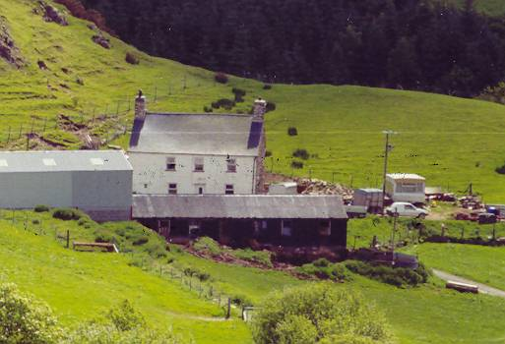

BRYN CYFERGID, Cwm Cynfal, Ffestiniog (O.S. 721 412) - 2001

We deal here with Sarah Jones (2) (1822 – 1899 – wife of Griffith Dafydd (1)) and her ancestors-up to 1841. See FelRh005 and the attached ref. 1 & 2
The family & time cards show the grandparents, parents and siblings of Sarah Jones (2). She was the youngest of seven children. We see the family hailing from Maentwrog. Her parents were married in 1802 when they were expecting Gwen, who was born in 1803. They lived at Ysgubor Hen (673 386), then Tyddyn Dewin (670 401), before moving to Bryncyfergid (circa 1815/1819). Three of their chidren died young; Mary(1) aged 14, Arthur aged 2 wks old and Sarah (1) 6mo.old . ). It was at Bryncyfergid that Mary(2) and Sarah(2) were born in Nov.1819 & Oct.1822 respectively. They were christened at Llan Ffestiniog Church on 14.11.1919 & 13.10. 1822.
In 1828 , the mother Sarah Humphrey died, aged 49. At the time the ages of the family were:- husband Morris Jones was 52, Gwen-25, Anne- 18, Mary(2)- 9 and our Sarah(2) was just 6 years old. In the adjacent farms, Brongoronwy and Bron yr Erw, lived Jane & John Lloyd and Catherine & Owen Owens. The family worshiped at either the old parish Church at Llan or at Coed bach which was on Bryncyfergid land. We do not know what schooling they were given. In the period 1830 to 1840 we have little written records of the family except that ref 3 quotes “ Morris Jones of Bryncyfergid used to collect socks and take them to Bala Fair. His wife (SH) would complete a sock in a day---the price varied--- some would fetch 10s 6d a pair” Morris Jones ran the farm and his business with the help of his four daughters and a servant . Gwen and Anne married young men from the adjacent farms of Cwm and Brynllech ( see ref.1.& separate notes).on 7.7.1840 Mary married Robert Joseph and Sarah(2) was the bridesmaid. Mary & Robert Joseph stayed at Bryncyfergid before they moved later to Tyddyn Gwyn Mawr ( see separate account of Tyddyn Gwyn Mawr and ref 4 &5).
In the 1841 census we have the following living at Bryncyfergid:- Morris Jones,65;Robert Joseph (son in law),25; Mary Joseph,(dau. & wife) 20 ; Sarah Jones (2) 19, & William Williams (servant?).
At Cwm farm was Pierce Edwards 34,and his wife Gwen, 38; Sarah,11; ,Joseph, 8; Jane,5; Morris,2,& Edward 1
We do not know where her sister Ann was in 1841. She has not as yet appeared on the Bryn llech although married to Cadwalader Jones. ( see ref. 1)
We had some difficulty with the records of the marriage of Sarah Jones (2) and Griffith Davies. (see ref.4 – Marr.Cert.) Note that the Rector, John Jones, had written Williams as the surname of the bridegroom. This was the modern system!. It is also obvious that the best man , John William – (who ever he was ) had signed the register on behalf of Griffith William ( Davies). We presume GD could not write. It seems that a small cross had been added after the signature. GD’s father was called Dafydd William ( Ty newydd Caeglas). We note also that the bridesmaid Mary, had used her maiden name, Jones, although she had been married a year to Edward Joseph.
The story of Sarah(2) continues from 1841onwards in the separate family tree of Felenrhyd Fawr. ( Vol. 17)
Ref 5
m.i. 610 Yma y mae’n gorwedd corph Jane gwraig Joseph Ephraim Bryn Cyfergid yr hon a fu farw yr 17fed o Fedi 1848 yn 50 oed Hefyd er serchus gof am Robert Joseph Tyddyn Gwyn( gynt of Bryn Cyfergid) yr hwn a fu farw Mawrth 23ydd 1892 yn 78 mlwydd oed. Hefyd Mary gwraig yr uchod R. Joseph a fu farw Mawrth 15 1909 yn 91 mlwydd oed “ Hyn a allodd hon hi a’i gwnaeth”

Ref.6
GO44 In memory of the children of Morris Jones of Bryncofergid by Sarah his wife, Arthur died January 5th 1814 aged 11 days, Sarah(1)died December 18th aged 6 weeks, Mary(1)died March26th 1819 aged 14years

GO45 Codwyd y maen hwn yn goffadwriaeth am Sarah gwraig Morris Jones o Fryncyfergid yr hon a fu farw Chewfror 21 1828 yn 48 oed. Hefyd y dywedig uchod Morris Jones yr hwn a fu farw ar y 13eg o Ebrill 1858 yn 82 flwyddyn oed

Where was Joseph Ephraim buried?

References:-
- Robert Griffith Work on Brynllech family Vol. 18 (ca 1930)
- Research notes of Sheelagh Williams (5.3.2001 ) (see Vol. 17A)
- Book “Hanes Plwyf Ffestiniog” by G.J. Williams 1882 – p 68.
- Photocopies of Cert. of Marr. 7.7.1840 (Mary) & 18.9.1841 ( Sarah)
- Memorial Inscription (m.i.610 ) at St Michel’s Llan Ffestiniog (GFHS)
- M.I GO 44 &45 at St Twrog’s Church (GFHS)

R.Price 10.01.2001

